December 15th, 2020

This cover letter is a formal submission of my manuscript titled “Training as Enrichment: A Critical Review”. I consider Applied Animal Behaviour Science to be the best vehicle for my publication because it is a broadly relevant applied animal behavior review with both basic and applied research implications for the welfare of captive animals.

I wish to confirm that there are no known conflicts of interest associated with this publication and there has been no significant financial support for this work that could have influenced its outcome.

I have given due consideration to the protection of intellectual property associated with this work and that there are no impediments to publication, including the timing of publication, with respect to intellectual property. In so doing I confirm that I have followed the regulations of my institution concerning intellectual property.

I understand that the Corresponding Author is the sole contact for the editorial process (including Editorial Manager and direct communications with the office). I am responsible for submissions of revisions and final approval of proofs. I have provided a current, correct email address: [edjfern@gmail.com](mailto:edjfern@gmail.com).

Thank you for considering my article for publication. I look forward to hearing your reply.

Sincerely,

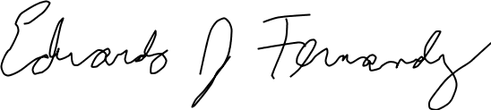

Eduardo J. Fernandez, PhD